Experiment 2

Aim: Create a simple cloud software application for Cab booking using any Cloud Service Provider to demonstrate SaaS.

Procedure

1. Open Zoho creator app

2. Loin the zoho app

3. On top right click on the new application

4. after clicking the new application click on the building From scratch

5. Then give the application name Cab booking after giving the name click Ok button

6. Go to Forms and select Cab booking.

7. Click on it changes what ever field names you want and done.

8. Now go to Cab booking Form and fill Your details.

OUTPUT

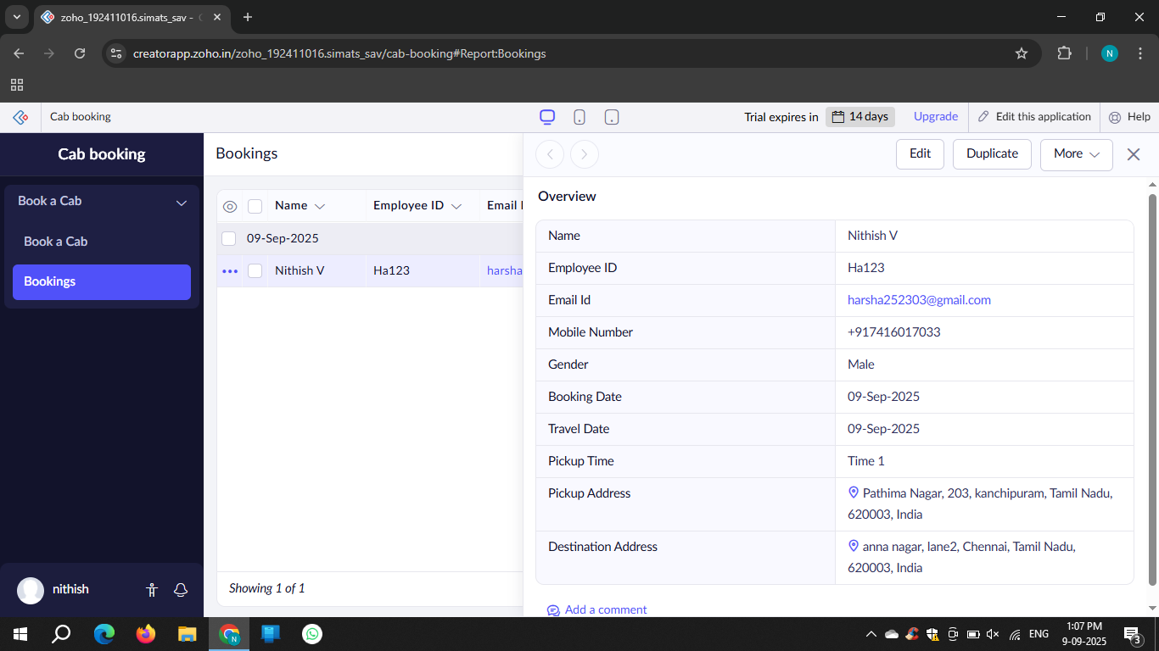

Result: The above experiment was executed Successfuly